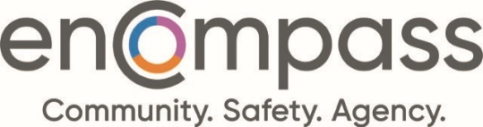

Governance Committee Meeting
Agenda
March 17, 2026
4:00 – 5:00 p.m.

JOIN THE MEETING NOW

- Welcome/Land Acknowledgement

- Approval of Agenda (Document 0.0)

- Approval of Previous Meeting’s Minutes – January 13, 2026 (Document 3.0)

- Board Development
4.1 Board Skills Matrix Review (Document 4.1)
4.2 Board Recruitment Update (Document 4.2)
4.3 Board Development Day Preparations (Discussion)

- Committee Terms of Reference Review (Document 5.0)

- Board and CEO Evaluations 2026 Time Frame (Discussion)

- 2026/2027 Meeting Dates (To Be Provided In-Meeting)

- Next Meeting (Information)
May 26, 2026

- In-Camera Session

- Adjournment

